A
PROJECT REPORT
ON
STUDENT MANAGEMENT SYSTEM
For
Teacher of computer application
Submitted
By
(Nameless | CheMeng,ChenPeng,LaiShan,YangYuMing)
R8J9400090,R8J9400069,R8J9400065,R8J00089 | 2019.05.12

Hainan University


PROJECT INDEX

S no. | Particulars | Page no.
1 | Project report cover | 1
2 | Project index | 2
3 | Team description & Overview  Certificate | 3
4 | Knowledge | 4
5 | Project report theme | 5-7
6 | Use case diagram | 8
7 | Module and division of labor | 9
8 | Each interface | 10-12
9 | Detailed code | 13-37

TEAM DESCRIPTION & OVERVIEW

TeamName: Nameless

MembersName:
YangYuMing,LaiShan,CheMeng,ChenPeng

Roll.No:
R8J9400089,R8J9400065,
R8J9400090,R8J9400069

TeamProject:Student Management System(A system which can help students search their personal information such as ID,name,country,address and so on)

Collage:Hainan University

CERTIFICATE

This is to certify that this report,titled Student Management System,embodies the original work done by YangYuMing, laiShan,CheMeng and ChenPeng in partial fulfillment of their course requirement at NIIT.

Coordinator：
ACKNOWLEDGEMENT

PROJECT REPORT

STUDENT MANAGEMENT
SYSTEM
Each student has his or her own personal information, and they always need to inquire about it. We make this project to solve all this, apply our project, the student needs to enter the account number and password to find the corresponding, in order to query the personal information.In our project, students need to input their own ID to get their own complete personal information, which greatly realizes the convenience.

Software Requirements
- jdk-6u3-fcs-bin-b05-windows-i586-p-24_sep_2007
- NetBeans IDE 7.1
- mysql-5.5.36-win32 (1)
- mysql-workbench-community-6.0.7-win32

Since then, our group members have applied these software to write the code, in view of all kinds of possible problems, the code has been modified, and the database has been made at the same time. After the completion of the project, we also produced ppt and the project report together, and completed the summary of the project.

SDLC of the Project
We used JDBC in the project.Our project has no big shortcomings but there is no bright spot in front of people, it is good when the operation is very simple, and the use will be quite convenient. Of course, we will gradually improve our project, give up the bad places, improve the advantages, so that it can really bring convenience to everyone.

Requirement Analysis
Before starting the project, the first thing which should be considered are the requirements.Our project is mainly for students and teachers, so we interviewed a number of students and teachers before we started the project planning to obtain their specific needs. Students need to check their personal data at any time, such as school number, address, age. And teachers need the same access to all kinds of information from students, as well as the right to modify.such as:
- Manual input：this is an important part of our program. We use manual input information to achieve login, query addition, delete and so on. You can also enter the account password, address, email and other data of the new user by entering it manually.
- Check: the program automatically judges the data type of the input information. When the input data type is inconsistent with the default data type inside the program, the program will pop up a page to inform the user that the input data type is wrong, and the information can be re-entered.

Software Design
Software design takes us a short period of time to conceive, so that we can achieve better results.

In software design, there are only two distinct types of activities:
- External design
- Internal design

External Design
External design involves conception, as well as the design of each module. In order to consider the external beauty of the project, we spent some time showing a variety of designs in each module, so that everyone can shine in front of us.

Internal Design
In the internal design, we use some simple code to connect each and build the whole program。

The software consists of the following interface：
- Initial interface
- Login interface
- New user registration interface
- Registration success interface
- Query interface

Initial interface
In this interface, you can enter the login interface simply by clicking the ‘Click’ button

Login interface
In this interface, you need to enter your account and password to log in to your account to query the information. If you do not have an account password, click the ‘New Student’ button to register your account.

New user registration interface
In this interface, you can register your new account. Here, enter your account number, password, address, email and other information to complete the registration of the new account.

Registration success interface
When you register successfully, you will enter this interface, which will allow you to return to the login interface.

Query interface
You can enter the name of the student to get all the information in the form, such as class, age, email address, etc.

End interface
This interface will appear when your query is over.

Database Design
The whole project is in fact an information management system, which interacts with the database having a number of tables. The tables with their column names and data type are as follows.

HRMS_USER_LOGIN
Field Name | Data Type | Size | Primary Key | Null
PASSWORD | Varchar2 | 20 |  | N
USER_NAME | Varchar2 | 20 |  | N
EMAIL | Varchar2 | 20
ADDRESS | Varchar2 | 20
DATE_OF_BIRTH | Date
AGE | Int
COUNTRY | char | 11

HRMS_STUDENT
Field Name | Data Type | Size | Primary Key | Null
STU_ID | Int |  | Y | N
STU_AGE | Int
STU_NAME | Varchar2 | 20
STU_EMAIL | Varchar2 | 20
STU_CLASS | Varchar2 | 20
STU_COLLEGE | Varchar2 | 20

Use Case diagram
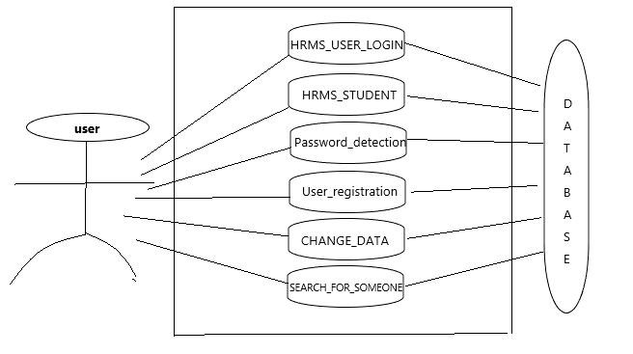

Data Flow Diagram:-

DFD of Login module

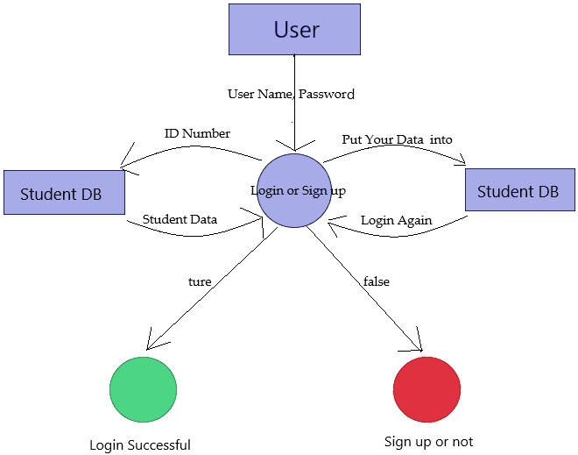

DEVELOPING A LOGIN MODULE
We developed a login module that allows the right person to access and change the database.The designed login module is being developed to allow only authorized person to access the available interface and links to add, update and search the important data. Every access to the system goes through this module and is forwarded to the authorized section only after the some mission of a valid login name and password

The development of this module includes writing code for the following files

- Welcome.java
- Login.java

DEVELOPING PROFILE MANAGEMENT MODULE
The profile of all employees is to be maintained using this application and development of this module includes designing user interface to enter new profile of an employee and editing the existing profile an employee. We can search an employee profile. The profile related information includes personal details, department name, designation, date of joining etc. The search form can help to see profile of an employee by just giving the search key, like an employee ID and employee NAME.

A profile record for an employee is stored in the table HRMS_EMPLOYEE. To complete the development of this module we need following files

- NewUser.java
- Register_Congratulation.java
- Search.java
- Exit.java

Work Done By | Work task | Starting Date | Ending Date | Duration(day)
YangYuming | Main Java Project,Project Report | 6 May 19 | 14 May 19 | 8
CheMeng | Database,PPT,Java Project | 6 May 19 | 14 May 19 | 9
ChenPeng | Database,Project Report | 6 May 19 | 15 May 19 | 9
LaiShan | Java Project,Project Report | 6 May 19 | 15 May19 | 9

This software has been developed in 2 weeks. I work on this project 3 hours a day.
The total hours = 11*3 = 33

Initial interface
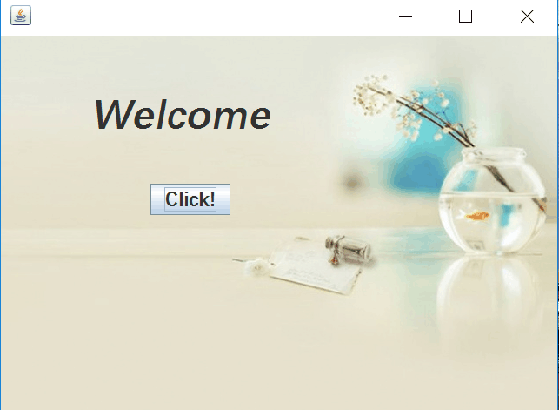

Login interface
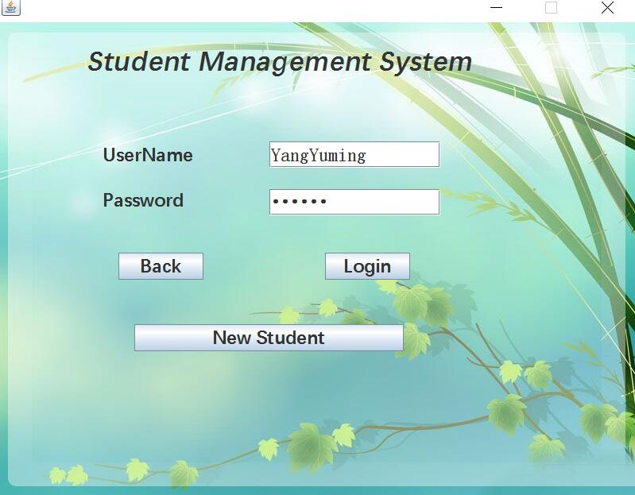
New user registration interface
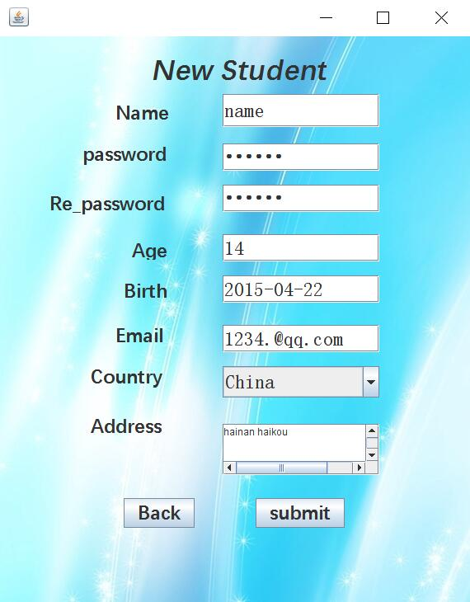
Registration success interface
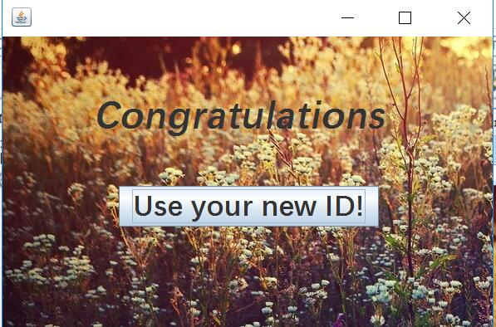

Query interface
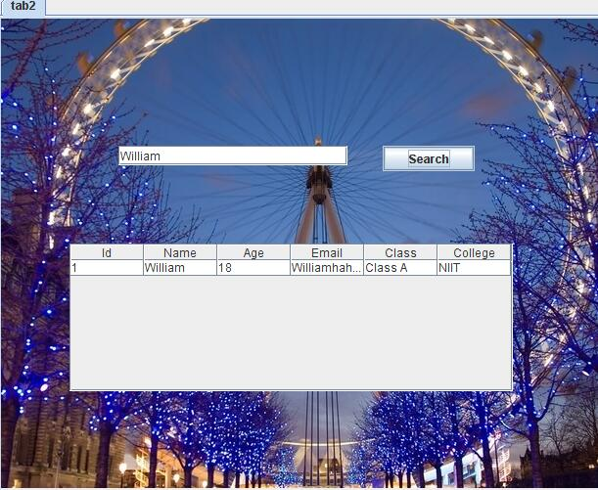
End interface
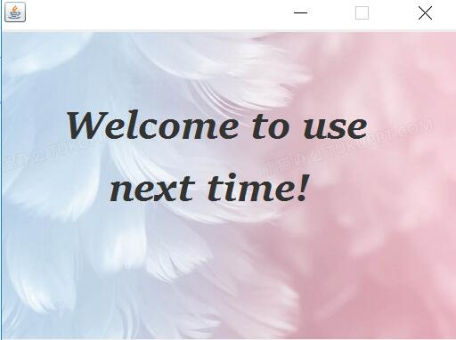

Initial interface
package interfaces;
import java.sql.*;
public class Welcome extends javax.swing.JFrame {

public Welcome() {
initComponents();
}

@SuppressWarnings("unchecked")
// <editor-fold defaultstate="collapsed" desc="Generated Code">
private void initComponents() {

jLabel1 = new javax.swing.JLabel();
jButton1 = new javax.swing.JButton();
ct1 = new javax.swing.JLabel();

setDefaultCloseOperation(javax.swing.WindowConstants.EXIT_ON_CLOSE);
getContentPane().setLayout(new org.netbeans.lib.awtextra.AbsoluteLayout());

jLabel1.setFont(new java.awt.Font("等线", 3, 48)); // NOI18N
jLabel1.setText("Welcome");
getContentPane().add(jLabel1, new org.netbeans.lib.awtextra.AbsoluteConstraints(104, 66, -1, -1));

jButton1.setFont(new java.awt.Font("等线", 1, 24)); // NOI18N
jButton1.setText("Click!");
jButton1.addActionListener(new java.awt.event.ActionListener() {
public void actionPerformed(java.awt.event.ActionEvent evt) {
jButton1ActionPerformed(evt);
}
});
getContentPane().add(jButton1, new org.netbeans.lib.awtextra.AbsoluteConstraints(172, 170, -1, -1));

ct1.setIcon(new javax.swing.ImageIcon(getClass().getResource("/interfaces/图片2.jpg"))); // NOI18N
getContentPane().add(ct1, new org.netbeans.lib.awtextra.AbsoluteConstraints(-140, -130, 780, 590));

pack();
}// </editor-fold>

private void jButton1ActionPerformed(java.awt.event.ActionEvent evt) {
Login_JFrame n=new Login_JFrame();
n.show(); // TODO add your handling code here:
}

public static void main(String args[]) {

//<editor-fold defaultstate="collapsed" desc=" Look and feel setting code (optional) ">

try {
for (javax.swing.UIManager.LookAndFeelInfo info : javax.swing.UIManager.getInstalledLookAndFeels()) {
if ("Nimbus".equals(info.getName())) {
javax.swing.UIManager.setLookAndFeel(info.getClassName());
break;
}
}
} catch (ClassNotFoundException ex) {
java.util.logging.Logger.getLogger(Welcome.class.getName()).log(java.util.logging.Level.SEVERE, null, ex);
} catch (InstantiationException ex) {
java.util.logging.Logger.getLogger(Welcome.class.getName()).log(java.util.logging.Level.SEVERE, null, ex);
} catch (IllegalAccessException ex) {
java.util.logging.Logger.getLogger(Welcome.class.getName()).log(java.util.logging.Level.SEVERE, null, ex);
} catch (javax.swing.UnsupportedLookAndFeelException ex) {
java.util.logging.Logger.getLogger(Welcome.class.getName()).log(java.util.logging.Level.SEVERE, null, ex);
}
//</editor-fold>

/*try
{
Connection co=aconnections.getConnection();
java.util.Date date=new java.util.Date();
java.sql.Date sqldate=new java.sql.Date(date.getTime());
java.sql.Timestamp sqlTime=new java.sql.Timestamp(date.getTime());

PreparedStatement ps=co.prepareStatement("insert into LoginDnt values(?,?)");

ps.setDate(1,sqldate);
ps.setTimestamp(2,sqlTime);
ps.executeUpdate();

String str="select * from LoginDnT order by LoginTime limit 1";
Statement st=co.createStatement();
ResultSet rs=st.executeQuery(str);
while(rs.next())
{
ct12.setText(rs.getString(1));
lli.setText(rs.getString(2));

}
ps.close();
}catch(Exception ex)
{
System.out.println(ex);
}*/
java.awt.EventQueue.invokeLater(new Runnable() {

@Override
public void run() {
new Welcome().setVisible(true);
}
});
}
// Variables declaration - do not modify
private javax.swing.JLabel ct1;
private javax.swing.JButton jButton1;
private javax.swing.JLabel jLabel1;
// End of variables declaration
}
Login interface
package interfaces;

import javax.swing.*;
import javax.swing.JPasswordField;
import java.sql.*;
import java.awt.*;
import java.util.*;
import java.util.logging.Level;
import java.util.logging.Logger;
import java.util.regex.Matcher;
import java.util.regex.Pattern;

public class Login_JFrame extends javax.swing.JFrame {

public Login_JFrame() {
initComponents();
}

@SuppressWarnings("unchecked")
// <editor-fold defaultstate="collapsed" desc="Generated Code">
private void initComponents() {

jLabel1 = new javax.swing.JLabel();
id = new javax.swing.JLabel();
pass = new javax.swing.JLabel();
un = new javax.swing.JTextField();
jButton1 = new javax.swing.JButton();
jButton2 = new javax.swing.JButton();
jButton3 = new javax.swing.JButton();
pas = new javax.swing.JPasswordField();
jLabel2 = new javax.swing.JLabel();

setDefaultCloseOperation(javax.swing.WindowConstants.EXIT_ON_CLOSE);
setForeground(new java.awt.Color(255, 0, 102));
setResizable(false);
getContentPane().setLayout(new org.netbeans.lib.awtextra.AbsoluteLayout());

jLabel1.setFont(new java.awt.Font("等线", 3, 36)); // NOI18N
jLabel1.setText("Student Management System");
getContentPane().add(jLabel1, new org.netbeans.lib.awtextra.AbsoluteConstraints(110, 30, 498, -1));

id.setFont(new java.awt.Font("等线", 1, 24)); // NOI18N
id.setText("UserName");
getContentPane().add(id, new org.netbeans.lib.awtextra.AbsoluteConstraints(130, 150, -1, 34));

pass.setFont(new java.awt.Font("等线", 1, 24)); // NOI18N
pass.setText("Password");
getContentPane().add(pass, new org.netbeans.lib.awtextra.AbsoluteConstraints(130, 210, -1, 29));

un.setFont(new java.awt.Font("宋体", 0, 24)); // NOI18N
getContentPane().add(un, new org.netbeans.lib.awtextra.AbsoluteConstraints(340, 150, 215, -1));

jButton1.setFont(new java.awt.Font("等线", 1, 24)); // NOI18N
jButton1.setText("New Student");
jButton1.addActionListener(new java.awt.event.ActionListener() {
public void actionPerformed(java.awt.event.ActionEvent evt) {
jButton1ActionPerformed(evt);
}
});
getContentPane().add(jButton1, new org.netbeans.lib.awtextra.AbsoluteConstraints(170, 380, 339, 34));

jButton2.setFont(new java.awt.Font("等线", 1, 24)); // NOI18N
jButton2.setText("Login");
jButton2.addActionListener(new java.awt.event.ActionListener() {
public void actionPerformed(java.awt.event.ActionEvent evt) {
jButton2ActionPerformed(evt);
}
});
getContentPane().add(jButton2, new org.netbeans.lib.awtextra.AbsoluteConstraints(410, 290, 107, 34));

jButton3.setFont(new java.awt.Font("等线", 1, 24)); // NOI18N
jButton3.setText("Back");
jButton3.addActionListener(new java.awt.event.ActionListener() {
public void actionPerformed(java.awt.event.ActionEvent evt) {
jButton3ActionPerformed(evt);
}
});
getContentPane().add(jButton3, new org.netbeans.lib.awtextra.AbsoluteConstraints(150, 290, 107, 34));

pas.setFont(new java.awt.Font("宋体", 0, 24)); // NOI18N
getContentPane().add(pas, new org.netbeans.lib.awtextra.AbsoluteConstraints(340, 210, 215, -1));

jLabel2.setIcon(new javax.swing.ImageIcon(getClass().getResource("/interfaces/图片.jpg"))); // NOI18N
getContentPane().add(jLabel2, new org.netbeans.lib.awtextra.AbsoluteConstraints(0, 0, -1, -1));

pack();
}// </editor-fold>

private void jButton1ActionPerformed(java.awt.event.ActionEvent evt) {
NewUser_JFrame n1 = new NewUser_JFrame();
n1.show();// TODO add your handling code here:
}

private void jButton2ActionPerformed(java.awt.event.ActionEvent evt) {
try {
//aconnections acon = new aconnections();
Connection conn = aconnections.getConnection();
Statement sta = conn.createStatement();
String str = "select * from user ";

String u = un.getText();
String pass = new String(pas.getPassword());
Boolean Myboolean, Myboolean1, Myboolean2;
Pattern Mypattern = Pattern.compile("^[a-zA-Z]+$");
Pattern Mypattern1 = Pattern.compile("^[a-zA-Z]\\.\\d{4}+$");
Matcher Mymatcher = Mypattern.matcher(u);
Matcher Mymatcher1 = Mypattern1.matcher(pass);
Myboolean = Mymatcher.matches();
Myboolean1 = Mymatcher1.matches();
if (Myboolean == false) {
JOptionPane.showMessageDialog(null, "sorry! PLease enter a correct user name!");
Myboolean = true;
} else if (Myboolean1 == false) {
JOptionPane.showMessageDialog(null, "sorry! PLease enter a correct password!");
Myboolean1 = true;
} else {
str = str + "where UserName='" + u + "'";
str = str + " and Password ='" + pass + "'";
ResultSet rs = sta.executeQuery(str);

if (rs != null) {
Search n5 = new Search();
n5.show();
} else {
JOptionPane.showMessageDialog(null, "sorry! User or password is wrong!!");
}
}

} catch (Exception ex) {
Logger.getLogger(Login_JFrame.class.getName()).log(Level.SEVERE, null, ex);
}// TODO add your handling code here:
}

private void jButton3ActionPerformed(java.awt.event.ActionEvent evt) {
Welcome n3 = new Welcome();
n3.show(); // TODO add your handling code here:
}

public static void main(String args[]) {

//<editor-fold defaultstate="collapsed" desc=" Look and feel setting code (optional) ">

try {
for (javax.swing.UIManager.LookAndFeelInfo info : javax.swing.UIManager.getInstalledLookAndFeels()) {
if ("Nimbus".equals(info.getName())) {
javax.swing.UIManager.setLookAndFeel(info.getClassName());
break;
}
}
} catch (ClassNotFoundException ex) {
java.util.logging.Logger.getLogger(Login_JFrame.class.getName()).log(java.util.logging.Level.SEVERE, null, ex);
} catch (InstantiationException ex) {
java.util.logging.Logger.getLogger(Login_JFrame.class.getName()).log(java.util.logging.Level.SEVERE, null, ex);
} catch (IllegalAccessException ex) {
java.util.logging.Logger.getLogger(Login_JFrame.class.getName()).log(java.util.logging.Level.SEVERE, null, ex);
} catch (javax.swing.UnsupportedLookAndFeelException ex) {
java.util.logging.Logger.getLogger(Login_JFrame.class.getName()).log(java.util.logging.Level.SEVERE, null, ex);
}
//</editor-fold>

java.awt.EventQueue.invokeLater(new Runnable() {

public void run() {
new Login_JFrame().setVisible(true);
}
});
}
// Variables declaration - do not modify
private javax.swing.JLabel id;
private javax.swing.JButton jButton1;
private javax.swing.JButton jButton2;
private javax.swing.JButton jButton3;
private javax.swing.JLabel jLabel1;
private javax.swing.JLabel jLabel2;
private javax.swing.JPasswordField pas;
private javax.swing.JLabel pass;
private javax.swing.JTextField un;
// End of variables declaration
}
New user registration interface

package interfaces;

import java.util.*;
import javax.swing.*;
import java.sql.*;
import java.util.logging.Level;
import java.util.logging.Logger;

/**
*
* @author lx
*/
public class NewUser_JFrame extends javax.swing.JFrame {

/**
* Creates new form newj2
*/
public NewUser_JFrame() {
initComponents();
}

/**
* This method is called from within the constructor to initialize the form.
* WARNING: Do NOT modify this code. The content of this method is always
* regenerated by the Form Editor.
*/
@SuppressWarnings("unchecked")
// <editor-fold defaultstate="collapsed" desc="Generated Code">
private void initComponents() {

jLabel11 = new javax.swing.JLabel();
jLabel1 = new javax.swing.JLabel();
jLabel2 = new javax.swing.JLabel();
jLabel3 = new javax.swing.JLabel();
jLabel4 = new javax.swing.JLabel();
jLabel5 = new javax.swing.JLabel();
jLabel6 = new javax.swing.JLabel();
jpf1 = new javax.swing.JPasswordField();
jtf2 = new javax.swing.JTextField();
jtf1 = new javax.swing.JTextField();
jpf2 = new javax.swing.JPasswordField();
jLabel7 = new javax.swing.JLabel();
jLabel8 = new javax.swing.JLabel();
jtf3 = new javax.swing.JTextField();
jtf4 = new javax.swing.JTextField();
jScrollPane1 = new javax.swing.JScrollPane();
jta1 = new javax.swing.JTextArea();
jButton1 = new javax.swing.JButton();
jButton2 = new javax.swing.JButton();
jLabel10 = new javax.swing.JLabel();
jLabel9 = new javax.swing.JLabel();
jl1 = new javax.swing.JComboBox();
jLabel12 = new javax.swing.JLabel();

jLabel11.setIcon(new javax.swing.ImageIcon(getClass().getResource("/interfaces/图片10.jpg"))); // NOI18N

setDefaultCloseOperation(javax.swing.WindowConstants.EXIT_ON_CLOSE);
getContentPane().setLayout(new org.netbeans.lib.awtextra.AbsoluteLayout());

jLabel1.setFont(new java.awt.Font("等线", 1, 24)); // NOI18N
jLabel1.setText("Age");
getContentPane().add(jLabel1, new org.netbeans.lib.awtextra.AbsoluteConstraints(160, 250, -1, 21));

jLabel2.setFont(new java.awt.Font("等线", 1, 24)); // NOI18N
jLabel2.setText("Name");
getContentPane().add(jLabel2, new org.netbeans.lib.awtextra.AbsoluteConstraints(140, 80, -1, -1));

jLabel3.setFont(new java.awt.Font("等线", 1, 24)); // NOI18N
jLabel3.setText("password");
getContentPane().add(jLabel3, new org.netbeans.lib.awtextra.AbsoluteConstraints(100, 130, -1, -1));

jLabel4.setFont(new java.awt.Font("等线", 1, 24)); // NOI18N
jLabel4.setText("Re_password");
getContentPane().add(jLabel4, new org.netbeans.lib.awtextra.AbsoluteConstraints(60, 190, -1, -1));

jLabel5.setFont(new java.awt.Font("等线", 1, 24)); // NOI18N
jLabel5.setText("Birth");
getContentPane().add(jLabel5, new org.netbeans.lib.awtextra.AbsoluteConstraints(150, 300, -1, 18));

jLabel6.setFont(new java.awt.Font("等线", 1, 24)); // NOI18N
jLabel6.setText("Email");
getContentPane().add(jLabel6, new org.netbeans.lib.awtextra.AbsoluteConstraints(140, 350, -1, -1));

jpf1.setFont(new java.awt.Font("宋体", 0, 24)); // NOI18N
getContentPane().add(jpf1, new org.netbeans.lib.awtextra.AbsoluteConstraints(270, 130, 190, -1));

jtf2.setFont(new java.awt.Font("宋体", 0, 24)); // NOI18N
getContentPane().add(jtf2, new org.netbeans.lib.awtextra.AbsoluteConstraints(270, 240, 190, -1));

jtf1.setFont(new java.awt.Font("宋体", 0, 24)); // NOI18N
getContentPane().add(jtf1, new org.netbeans.lib.awtextra.AbsoluteConstraints(270, 70, 190, 40));

jpf2.setFont(new java.awt.Font("宋体", 0, 24)); // NOI18N
getContentPane().add(jpf2, new org.netbeans.lib.awtextra.AbsoluteConstraints(270, 180, 190, -1));
getContentPane().add(jLabel7, new org.netbeans.lib.awtextra.AbsoluteConstraints(423, 350, 31, -1));

jLabel8.setFont(new java.awt.Font("等线", 1, 24)); // NOI18N
jLabel8.setText("Address");
getContentPane().add(jLabel8, new org.netbeans.lib.awtextra.AbsoluteConstraints(110, 460, -1, -1));

jtf3.setFont(new java.awt.Font("宋体", 0, 24)); // NOI18N
getContentPane().add(jtf3, new org.netbeans.lib.awtextra.AbsoluteConstraints(270, 350, 190, -1));

jtf4.setFont(new java.awt.Font("宋体", 0, 24)); // NOI18N
jtf4.addActionListener(new java.awt.event.ActionListener() {
public void actionPerformed(java.awt.event.ActionEvent evt) {
jtf4ActionPerformed(evt);
}
});
getContentPane().add(jtf4, new org.netbeans.lib.awtextra.AbsoluteConstraints(270, 290, 190, -1));

jta1.setColumns(20);
jta1.setRows(5);
jScrollPane1.setViewportView(jta1);

getContentPane().add(jScrollPane1, new org.netbeans.lib.awtextra.AbsoluteConstraints(270, 470, 190, 62));

jButton1.setFont(new java.awt.Font("等线", 1, 24)); // NOI18N
jButton1.setText("Back");
jButton1.addActionListener(new java.awt.event.ActionListener() {
public void actionPerformed(java.awt.event.ActionEvent evt) {
jButton1ActionPerformed(evt);
}
});
getContentPane().add(jButton1, new org.netbeans.lib.awtextra.AbsoluteConstraints(150, 560, -1, -1));

jButton2.setFont(new java.awt.Font("等线", 1, 24)); // NOI18N
jButton2.setText("submit");
jButton2.addActionListener(new java.awt.event.ActionListener() {
public void actionPerformed(java.awt.event.ActionEvent evt) {
jButton2ActionPerformed(evt);
}
});
getContentPane().add(jButton2, new org.netbeans.lib.awtextra.AbsoluteConstraints(310, 560, -1, -1));

jLabel10.setFont(new java.awt.Font("等线", 3, 36)); // NOI18N
jLabel10.setText("New Student");
getContentPane().add(jLabel10, new org.netbeans.lib.awtextra.AbsoluteConstraints(183, 22, -1, -1));

jLabel9.setFont(new java.awt.Font("等线", 1, 24)); // NOI18N
jLabel9.setText("Country");
getContentPane().add(jLabel9, new org.netbeans.lib.awtextra.AbsoluteConstraints(110, 400, -1, -1));

jl1.setFont(new java.awt.Font("宋体", 0, 24)); // NOI18N
jl1.setModel(new javax.swing.DefaultComboBoxModel(new String[] { "America", "Australia", "Canada", "China", "India", "Italy", "Japan", "Korea", " " }));
getContentPane().add(jl1, new org.netbeans.lib.awtextra.AbsoluteConstraints(270, 400, 190, -1));

jLabel12.setIcon(new javax.swing.ImageIcon(getClass().getResource("/interfaces/图片10.jpg"))); // NOI18N
getContentPane().add(jLabel12, new org.netbeans.lib.awtextra.AbsoluteConstraints(-120, -10, 690, 700));

pack();
}// </editor-fold>

private void jButton2ActionPerformed(java.awt.event.ActionEvent evt) {
try {
Connection conn=aconnections.getConnection();
//引用acconection类中的getConnection()方法，让数据库与java连接
String sql="insert into student values (?,?,?,?,?,?,?,?)";
String sq2="insert into user values (?,?,?,?,?,?,?,?)";
//可变化的语句
PreparedStatement pdt,pdt2;
pdt = conn.prepareStatement(sql);
pdt2 = conn.prepareStatement(sq2);
pdt.setString(1,jtf1.getText());
pdt.setString(2,jpf1.getText());
pdt.setString(3,jpf2.getText());
//获取pass和re_pass。
if(jpf1.getText().equals(jpf2.getText()))
{
pdt.setString(4,jtf2.getText());
pdt.setString(5,jtf3.getText());
pdt.setString(6,jtf4.getText());
pdt.setString(7,jl1.getSelectedItem().toString());
//.getSelectedItem().toString()仅支持组合框使用，并返回一个字符串。
pdt.setString(8,jta1.getText());

pdt2.setString(1,jtf1.getText());
pdt2.setString(2,jpf1.getText());
pdt2.setString(3,jpf2.getText());
pdt2.setString(4,jtf2.getText());
pdt2.setString(5,jtf3.getText());
pdt2.setString(6,jtf4.getText());
pdt2.setString(7,jl1.getSelectedItem().toString());
pdt.setString(8,jta1.getText());
Register_Congratulations n4=new Register_Congratulations();
n4.show();
}//录入用户输入的信息
else
{
System.out.println("The re_password is wrong");
}
} catch (Exception ex) {

Logger.getLogger(NewUser_JFrame.class.getName()).log(Level.SEVERE, null, ex);
System.out.println("Failure to enter information.");
}
//aconnections acon2=new aconnections();
// TODO add your handling code here:
}

private void jButton1ActionPerformed(java.awt.event.ActionEvent evt) {
Login_JFrame n=new Login_JFrame();
n.show(); // TODO add your handling code here:
}

private void jtf4ActionPerformed(java.awt.event.ActionEvent evt) {
// TODO add your handling code here:
}

public static void main(String args[]) {

//<editor-fold defaultstate="collapsed" desc=" Look and feel setting code (optional) ">

try {
for (javax.swing.UIManager.LookAndFeelInfo info : javax.swing.UIManager.getInstalledLookAndFeels()) {
if ("Nimbus".equals(info.getName())) {
javax.swing.UIManager.setLookAndFeel(info.getClassName());
break;
}
}
} catch (ClassNotFoundException ex) {
java.util.logging.Logger.getLogger(NewUser_JFrame.class.getName()).log(java.util.logging.Level.SEVERE, null, ex);
} catch (InstantiationException ex) {
java.util.logging.Logger.getLogger(NewUser_JFrame.class.getName()).log(java.util.logging.Level.SEVERE, null, ex);
} catch (IllegalAccessException ex) {
java.util.logging.Logger.getLogger(NewUser_JFrame.class.getName()).log(java.util.logging.Level.SEVERE, null, ex);
} catch (javax.swing.UnsupportedLookAndFeelException ex) {
java.util.logging.Logger.getLogger(NewUser_JFrame.class.getName()).log(java.util.logging.Level.SEVERE, null, ex);
}
//</editor-fold>

/*
* Create and display the form
*/
java.awt.EventQueue.invokeLater(new Runnable() {

public void run() {
new NewUser_JFrame().setVisible(true);
}
});
}
// Variables declaration - do not modify
private javax.swing.JButton jButton1;
private javax.swing.JButton jButton2;
private javax.swing.JLabel jLabel1;
private javax.swing.JLabel jLabel10;
private javax.swing.JLabel jLabel11;
private javax.swing.JLabel jLabel12;
private javax.swing.JLabel jLabel2;
private javax.swing.JLabel jLabel3;
private javax.swing.JLabel jLabel4;
private javax.swing.JLabel jLabel5;
private javax.swing.JLabel jLabel6;
private javax.swing.JLabel jLabel7;
private javax.swing.JLabel jLabel8;
private javax.swing.JLabel jLabel9;
private javax.swing.JScrollPane jScrollPane1;
private javax.swing.JComboBox jl1;
private javax.swing.JPasswordField jpf1;
private javax.swing.JPasswordField jpf2;
private javax.swing.JTextArea jta1;
private javax.swing.JTextField jtf1;
private javax.swing.JTextField jtf2;
private javax.swing.JTextField jtf3;
private javax.swing.JTextField jtf4;
// End of variables declaration
}
Registration success interface

package interfaces;

/**
*
* @author lx
*/
public class Register_Congratulations extends javax.swing.JFrame {

/**
* Creates new form newj4
*/
public Register_Congratulations() {
initComponents();
}

/**
* This method is called from within the constructor to initialize the form.
* WARNING: Do NOT modify this code. The content of this method is always
* regenerated by the Form Editor.
*/
@SuppressWarnings("unchecked")
// <editor-fold defaultstate="collapsed" desc="Generated Code">
private void initComponents() {

jLabel1 = new javax.swing.JLabel();
jButton1 = new javax.swing.JButton();
jLabel2 = new javax.swing.JLabel();
jLabel3 = new javax.swing.JLabel();

setDefaultCloseOperation(javax.swing.WindowConstants.EXIT_ON_CLOSE);
getContentPane().setLayout(new org.netbeans.lib.awtextra.AbsoluteLayout());

jLabel1.setFont(new java.awt.Font("等线", 3, 48)); // NOI18N
jLabel1.setText("Congratulations");
getContentPane().add(jLabel1, new org.netbeans.lib.awtextra.AbsoluteConstraints(110, 70, -1, -1));

jButton1.setFont(new java.awt.Font("等线", 1, 36)); // NOI18N
jButton1.setText("Use your new ID!");
jButton1.addActionListener(new java.awt.event.ActionListener() {
public void actionPerformed(java.awt.event.ActionEvent evt) {
jButton1ActionPerformed(evt);
}
});
getContentPane().add(jButton1, new org.netbeans.lib.awtextra.AbsoluteConstraints(140, 180, -1, -1));

jLabel2.setIcon(new javax.swing.ImageIcon(getClass().getResource("/interfaces/图片14.jpg"))); // NOI18N
getContentPane().add(jLabel2, new org.netbeans.lib.awtextra.AbsoluteConstraints(0, -80, 590, 430));

jLabel3.setText("jLabel3");
getContentPane().add(jLabel3, new org.netbeans.lib.awtextra.AbsoluteConstraints(50, 10, -1, -1));

pack();
}// </editor-fold>

private void jButton1ActionPerformed(java.awt.event.ActionEvent evt) {
Login_JFrame n=new Login_JFrame();
n.show(); // TODO add your handling code here:
}

/**
* @param args the command line arguments
*/
public static void main(String args[]) {
/*
* Set the Nimbus look and feel
*/
//<editor-fold defaultstate="collapsed" desc=" Look and feel setting code (optional) ">
/*
* If Nimbus (introduced in Java SE 6) is not available, stay with the
* default look and feel. For details see
* http://download.oracle.com/javase/tutorial/uiswing/lookandfeel/plaf.html
*/
try {
for (javax.swing.UIManager.LookAndFeelInfo info : javax.swing.UIManager.getInstalledLookAndFeels()) {
if ("Nimbus".equals(info.getName())) {
javax.swing.UIManager.setLookAndFeel(info.getClassName());
break;
}
}
} catch (ClassNotFoundException ex) {
java.util.logging.Logger.getLogger(Register_Congratulations.class.getName()).log(java.util.logging.Level.SEVERE, null, ex);
} catch (InstantiationException ex) {
java.util.logging.Logger.getLogger(Register_Congratulations.class.getName()).log(java.util.logging.Level.SEVERE, null, ex);
} catch (IllegalAccessException ex) {
java.util.logging.Logger.getLogger(Register_Congratulations.class.getName()).log(java.util.logging.Level.SEVERE, null, ex);
} catch (javax.swing.UnsupportedLookAndFeelException ex) {
java.util.logging.Logger.getLogger(Register_Congratulations.class.getName()).log(java.util.logging.Level.SEVERE, null, ex);
}
//</editor-fold>

/*
* Create and display the form
*/
java.awt.EventQueue.invokeLater(new Runnable() {

public void run() {
new Register_Congratulations().setVisible(true);
}
});
}
// Variables declaration - do not modify
private javax.swing.JButton jButton1;
private javax.swing.JLabel jLabel1;
private javax.swing.JLabel jLabel2;
private javax.swing.JLabel jLabel3;
// End of variables declaration
}
Query interface

package interfaces;
import java.sql.*;
import java.util.logging.Level;
import java.util.logging.Logger;
import javax.swing.*;
import javax.swing.table.DefaultTableModel;
public class Search extends javax.swing.JFrame {
private String[] a;

public Search() {
initComponents();
}

@SuppressWarnings("unchecked")
// <editor-fold defaultstate="collapsed" desc="Generated Code">
private void initComponents() {

jPanel1 = new javax.swing.JPanel();
st = new javax.swing.JTextField();
jb2 = new javax.swing.JButton();
jScrollPane2 = new javax.swing.JScrollPane();
jTable1 = new javax.swing.JTable();
jLabel3 = new javax.swing.JLabel();
jTabbedPane1 = new javax.swing.JTabbedPane();
jPanel2 = new javax.swing.JPanel();
jScrollPane3 = new javax.swing.JScrollPane();
jt = new javax.swing.JTable();
jb1 = new javax.swing.JButton();
jtf1 = new javax.swing.JTextField();
jLabel1 = new javax.swing.JLabel();
jLabel2 = new javax.swing.JLabel();
jLabel4 = new javax.swing.JLabel();
jButton1 = new javax.swing.JButton();
jLabel5 = new javax.swing.JLabel();

st.addActionListener(new java.awt.event.ActionListener() {
public void actionPerformed(java.awt.event.ActionEvent evt) {
stActionPerformed(evt);
}
});

jb2.setText("Search");
jb2.addActionListener(new java.awt.event.ActionListener() {
public void actionPerformed(java.awt.event.ActionEvent evt) {
jb2ActionPerformed(evt);
}
});

jTable1.setModel(new javax.swing.table.DefaultTableModel(
new Object [][] {
{null, null, null, null},
{null, null, null, null},
{null, null, null, null},
{null, null, null, null}
},
new String [] {
"Title 1", "Title 2", "Title 3", "Title 4"
}
));
jScrollPane2.setViewportView(jTable1);

javax.swing.GroupLayout jPanel1Layout = new javax.swing.GroupLayout(jPanel1);
jPanel1.setLayout(jPanel1Layout);
jPanel1Layout.setHorizontalGroup(
jPanel1Layout.createParallelGroup(javax.swing.GroupLayout.Alignment.LEADING)
.addGroup(jPanel1Layout.createSequentialGroup()
.addGroup(jPanel1Layout.createParallelGroup(javax.swing.GroupLayout.Alignment.LEADING)
.addGroup(jPanel1Layout.createSequentialGroup()
.addGap(33, 33, 33)
.addComponent(st, javax.swing.GroupLayout.PREFERRED_SIZE, 283, javax.swing.GroupLayout.PREFERRED_SIZE)
.addPreferredGap(javax.swing.LayoutStyle.ComponentPlacement.RELATED)
.addComponent(jb2))
.addGroup(jPanel1Layout.createSequentialGroup()
.addGap(22, 22, 22)
.addComponent(jScrollPane2, javax.swing.GroupLayout.PREFERRED_SIZE, 452, javax.swing.GroupLayout.PREFERRED_SIZE)))
.addContainerGap(22, Short.MAX_VALUE))
);
jPanel1Layout.setVerticalGroup(
jPanel1Layout.createParallelGroup(javax.swing.GroupLayout.Alignment.LEADING)
.addGroup(jPanel1Layout.createSequentialGroup()
.addGap(32, 32, 32)
.addGroup(jPanel1Layout.createParallelGroup(javax.swing.GroupLayout.Alignment.BASELINE)
.addComponent(st, javax.swing.GroupLayout.PREFERRED_SIZE, javax.swing.GroupLayout.DEFAULT_SIZE, javax.swing.GroupLayout.PREFERRED_SIZE)
.addComponent(jb2))
.addGap(18, 18, 18)
.addComponent(jScrollPane2, javax.swing.GroupLayout.PREFERRED_SIZE, 127, javax.swing.GroupLayout.PREFERRED_SIZE)
.addContainerGap(162, Short.MAX_VALUE))
);

jLabel3.setIcon(new javax.swing.ImageIcon(getClass().getResource("/interfaces/图片12.jpg"))); // NOI18N

setDefaultCloseOperation(javax.swing.WindowConstants.EXIT_ON_CLOSE);

jPanel2.setLayout(new org.netbeans.lib.awtextra.AbsoluteLayout());

jt.setModel(new javax.swing.table.DefaultTableModel(
new Object [][] {
{null, null, null, null},
{null, null, null, null},
{null, null, null, null},
{null, null, null, null}
},
new String [] {
"Title 1", "Title 2", "Title 3", "Title 4"
}
));
jScrollPane3.setViewportView(jt);

jPanel2.add(jScrollPane3, new org.netbeans.lib.awtextra.AbsoluteConstraints(70, 230, -1, 151));

jb1.setText("Search");
jb1.addActionListener(new java.awt.event.ActionListener() {
public void actionPerformed(java.awt.event.ActionEvent evt) {
jb1ActionPerformed(evt);
}
});
jPanel2.add(jb1, new org.netbeans.lib.awtextra.AbsoluteConstraints(390, 130, 94, -1));

jtf1.addActionListener(new java.awt.event.ActionListener() {
public void actionPerformed(java.awt.event.ActionEvent evt) {
jtf1ActionPerformed(evt);
}
});
jPanel2.add(jtf1, new org.netbeans.lib.awtextra.AbsoluteConstraints(120, 130, 234, -1));
jPanel2.add(jLabel1, new org.netbeans.lib.awtextra.AbsoluteConstraints(0, 0, -1, -1));
jPanel2.add(jLabel2, new org.netbeans.lib.awtextra.AbsoluteConstraints(0, 0, -1, -1));

jLabel4.setText("jLabel4");
jPanel2.add(jLabel4, new org.netbeans.lib.awtextra.AbsoluteConstraints(290, 260, -1, -1));

jButton1.setText("Exit");
jButton1.addActionListener(new java.awt.event.ActionListener() {
public void actionPerformed(java.awt.event.ActionEvent evt) {
jButton1ActionPerformed(evt);
}
});
jPanel2.add(jButton1, new org.netbeans.lib.awtextra.AbsoluteConstraints(540, 20, -1, -1));

jLabel5.setIcon(new javax.swing.ImageIcon(getClass().getResource("/interfaces/图片12.jpg"))); // NOI18N
jPanel2.add(jLabel5, new org.netbeans.lib.awtextra.AbsoluteConstraints(-180, 0, 800, 530));

jTabbedPane1.addTab("inquire", jPanel2);

javax.swing.GroupLayout layout = new javax.swing.GroupLayout(getContentPane());
getContentPane().setLayout(layout);
layout.setHorizontalGroup(
layout.createParallelGroup(javax.swing.GroupLayout.Alignment.LEADING)
.addComponent(jTabbedPane1, javax.swing.GroupLayout.PREFERRED_SIZE, 615, Short.MAX_VALUE)
);
layout.setVerticalGroup(
layout.createParallelGroup(javax.swing.GroupLayout.Alignment.LEADING)
.addComponent(jTabbedPane1, javax.swing.GroupLayout.DEFAULT_SIZE, 639, Short.MAX_VALUE)
);

pack();
}// </editor-fold>

private void jb2ActionPerformed(java.awt.event.ActionEvent evt) {
// TODO add your handling code here:
}

private void stActionPerformed(java.awt.event.ActionEvent evt) {
// TODO add your handling code here:
}

private void jtf1ActionPerformed(java.awt.event.ActionEvent evt) {
// TODO add your handling code here:
}

private void jb1ActionPerformed(java.awt.event.ActionEvent evt) {
try
{
Connection con=aconnections.getConnection();
Statement statement=con.createStatement();
ResultSet rs=statement.executeQuery("select * from student where Name ='"+jtf1 .getText()+"'");
ResultSetMetaData rsmd=rs.getMetaData();
int columnCount=rsmd.getColumnCount();
DefaultTableModel tm=(DefaultTableModel) jt.getModel();
tm.setColumnCount(0);
tm.setRowCount(0);
while(rs.next())
{
for(int i=1;i<=columnCount;i++)
{
tm.addColumn(rsmd.getColumnName(i));
a=new String[columnCount];
for(int s=0;s<columnCount;s++)
{
a[s]=rs.getString(s+1);
}
}
tm.addRow(a);
}
if(jtf1.getText().length()==0)
{
JOptionPane.showMessageDialog(this,"Empty user name","Waring",JOptionPane.WARNING_MESSAGE);
}
tm.fireTableDataChanged();
rs.close();
statement.close();
//String text1=st.getText();

//st表示serch text是我们想要搜索的关键词。

}catch(Exception e)
{
JOptionPane.showMessageDialog(null, "sorry! Something is wrong!!");
} // TODO add your handling code here:
}

private void jButton1ActionPerformed(java.awt.event.ActionEvent evt) {
newj6 newj=new newj6();
newj.show();// TODO add your handling code here:
}

public static void main(String args[]) {

//<editor-fold defaultstate="collapsed" desc=" Look and feel setting code (optional) ">

try {
for (javax.swing.UIManager.LookAndFeelInfo info : javax.swing.UIManager.getInstalledLookAndFeels()) {
if ("Nimbus".equals(info.getName())) {
javax.swing.UIManager.setLookAndFeel(info.getClassName());
break;
}
}
} catch (ClassNotFoundException ex) {
java.util.logging.Logger.getLogger(Search.class.getName()).log(java.util.logging.Level.SEVERE, null, ex);
} catch (InstantiationException ex) {
java.util.logging.Logger.getLogger(Search.class.getName()).log(java.util.logging.Level.SEVERE, null, ex);
} catch (IllegalAccessException ex) {
java.util.logging.Logger.getLogger(Search.class.getName()).log(java.util.logging.Level.SEVERE, null, ex);
} catch (javax.swing.UnsupportedLookAndFeelException ex) {
java.util.logging.Logger.getLogger(Search.class.getName()).log(java.util.logging.Level.SEVERE, null, ex);
}
//</editor-fold>

java.awt.EventQueue.invokeLater(new Runnable() {

public void run() {
new Search().setVisible(true);
}
});
}
// Variables declaration - do not modify
private javax.swing.JButton jButton1;
private javax.swing.JLabel jLabel1;
private javax.swing.JLabel jLabel2;
private javax.swing.JLabel jLabel3;
private javax.swing.JLabel jLabel4;
private javax.swing.JLabel jLabel5;
private javax.swing.JPanel jPanel1;
private javax.swing.JPanel jPanel2;
private javax.swing.JScrollPane jScrollPane2;
private javax.swing.JScrollPane jScrollPane3;
private javax.swing.JTabbedPane jTabbedPane1;
private javax.swing.JTable jTable1;
private javax.swing.JButton jb1;
private javax.swing.JButton jb2;
private javax.swing.JTable jt;
private javax.swing.JTextField jtf1;
private javax.swing.JTextField st;
// End of variables declaration
}
End interface
package interfaces;

public class newj6 extends javax.swing.JFrame {

public newj6() {
initComponents();
}

@SuppressWarnings("unchecked")
// <editor-fold defaultstate="collapsed" desc="Generated Code">
private void initComponents() {

jLabel3 = new javax.swing.JLabel();
jLabel6 = new javax.swing.JLabel();
jLabel1 = new javax.swing.JLabel();
jLabel4 = new javax.swing.JLabel();
jLabel5 = new javax.swing.JLabel();
jLabel2 = new javax.swing.JLabel();
jLabel7 = new javax.swing.JLabel();

jLabel3.setText("jLabel3");

jLabel6.setIcon(new javax.swing.ImageIcon(getClass().getResource("/interfaces/图片20.jpg"))); // NOI18N

setDefaultCloseOperation(javax.swing.WindowConstants.EXIT_ON_CLOSE);
setResizable(false);
getContentPane().setLayout(new org.netbeans.lib.awtextra.AbsoluteLayout());

jLabel1.setFont(new java.awt.Font("Sitka Subheading", 3, 48)); // NOI18N
jLabel1.setText("Welcome to use ");
getContentPane().add(jLabel1, new org.netbeans.lib.awtextra.AbsoluteConstraints(70, 80, -1, -1));
getContentPane().add(jLabel4, new org.netbeans.lib.awtextra.AbsoluteConstraints(0, 0, -1, -1));
getContentPane().add(jLabel5, new org.netbeans.lib.awtextra.AbsoluteConstraints(0, 0, -1, -1));

jLabel2.setFont(new java.awt.Font("Sitka Subheading", 3, 48)); // NOI18N
jLabel2.setText("next time!");
getContentPane().add(jLabel2, new org.netbeans.lib.awtextra.AbsoluteConstraints(120, 150, -1, -1));

jLabel7.setIcon(new javax.swing.ImageIcon(getClass().getResource("/interfaces/图片20.jpg"))); // NOI18N
jLabel7.setFocusable(false);
getContentPane().add(jLabel7, new org.netbeans.lib.awtextra.AbsoluteConstraints(-70, 0, 580, 350));

pack();
}// </editor-fold>

public static void main(String args[]) {
//<editor-fold defaultstate="collapsed" desc=" Look and feel setting code (optional) ">

try {
for (javax.swing.UIManager.LookAndFeelInfo info : javax.swing.UIManager.getInstalledLookAndFeels()) {
if ("Nimbus".equals(info.getName())) {
javax.swing.UIManager.setLookAndFeel(info.getClassName());
break;
}
}
} catch (ClassNotFoundException ex) {
java.util.logging.Logger.getLogger(newj6.class.getName()).log(java.util.logging.Level.SEVERE, null, ex);
} catch (InstantiationException ex) {
java.util.logging.Logger.getLogger(newj6.class.getName()).log(java.util.logging.Level.SEVERE, null, ex);
} catch (IllegalAccessException ex) {
java.util.logging.Logger.getLogger(newj6.class.getName()).log(java.util.logging.Level.SEVERE, null, ex);
} catch (javax.swing.UnsupportedLookAndFeelException ex) {
java.util.logging.Logger.getLogger(newj6.class.getName()).log(java.util.logging.Level.SEVERE, null, ex);
}
//</editor-fold>
java.awt.EventQueue.invokeLater(new Runnable() {

public void run() {
new newj6().setVisible(true);
}
});
}
// Variables declaration - do not modify
private javax.swing.JLabel jLabel1;
private javax.swing.JLabel jLabel2;
private javax.swing.JLabel jLabel3;
private javax.swing.JLabel jLabel4;
private javax.swing.JLabel jLabel5;
private javax.swing.JLabel jLabel6;
private javax.swing.JLabel jLabel7;
// End of variables declaration
}
Connection
package interfaces;

import java.sql.Connection;
import java.sql.DriverManager;

public class aconnections {

static private Connection connection;
public static Connection getConnection() throws Exception
{
if(connection==null)
{
Class.forName("com.mysql.jdbc.Driver");
connection=DriverManager.getConnection("jdbc:mysql://localhost:3306/managementsystem","root","1234");
}
if(connection!=null)
{
System.out.println("Connected to the managementsystem!");
}
return connection;
}
}

